# Project Design Phase SolutionArchitecture

|  |  |
| --- | --- |
| Date | 3 July 2025 |
| TeamID | LTVIP2025TMID60948 |
| ProjectName | Measuringthepulseofprosperity:anindexof  economicfreedom |
| MaximumMarks | 4Marks |

**Solution Architecture:**

Solutionarchitectureisacomplexprocess–withmanysub-processes–thatbridges the gap between business problems and technology solutions. Its goals are to:

* Findthebesttechsolutiontosolveexistingbusinessproblems.
* Describethestructure,characteristics,behaviour,andotheraspectsofthe software to project stakeholders.
* Definefeatures,developmentphases,andsolutionrequirements.
* Providespecificationsaccordingtowhichthesolutionisdefined,managed, and delivered.

# SolutionArchitectureDiagram:

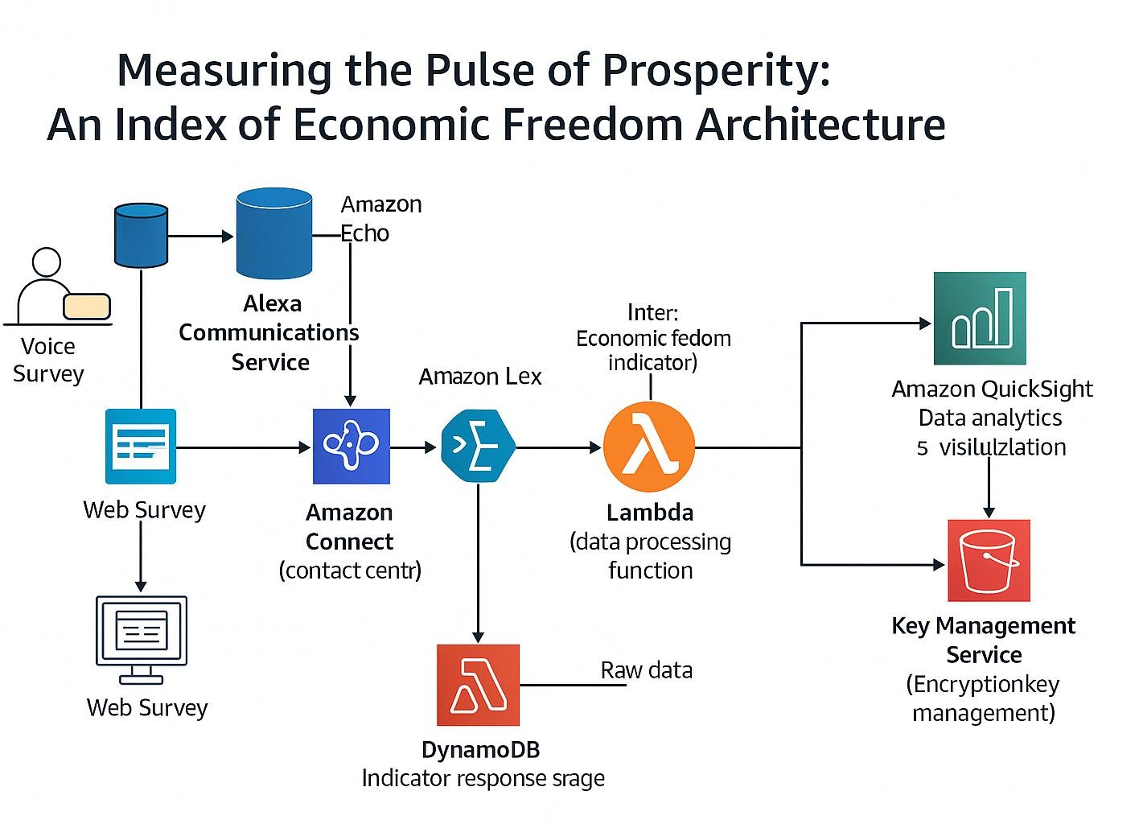

**Reference:**[**https://aws.amazon.com/blogs/industries/voice-applications-in-clinical-research-powered-by-ai-on-aws-part-1-architecture-and-design-considerations/**](https://aws.amazon.com/blogs/industries/voice-applications-in-clinical-research-powered-by-ai-on-aws-part-1-architecture-and-design-considerations/)